**Assignment -4**

|  |  |
| --- | --- |
| **Assignment Date** | 25 October 2022 |
| **Student Name** | SUBASHINI.B |
| **Student Roll Number** | 110819205019 |
| **Maximum Marks** | 2 Marks |

1. Pull an Image from docker hub and run it in docker playground.

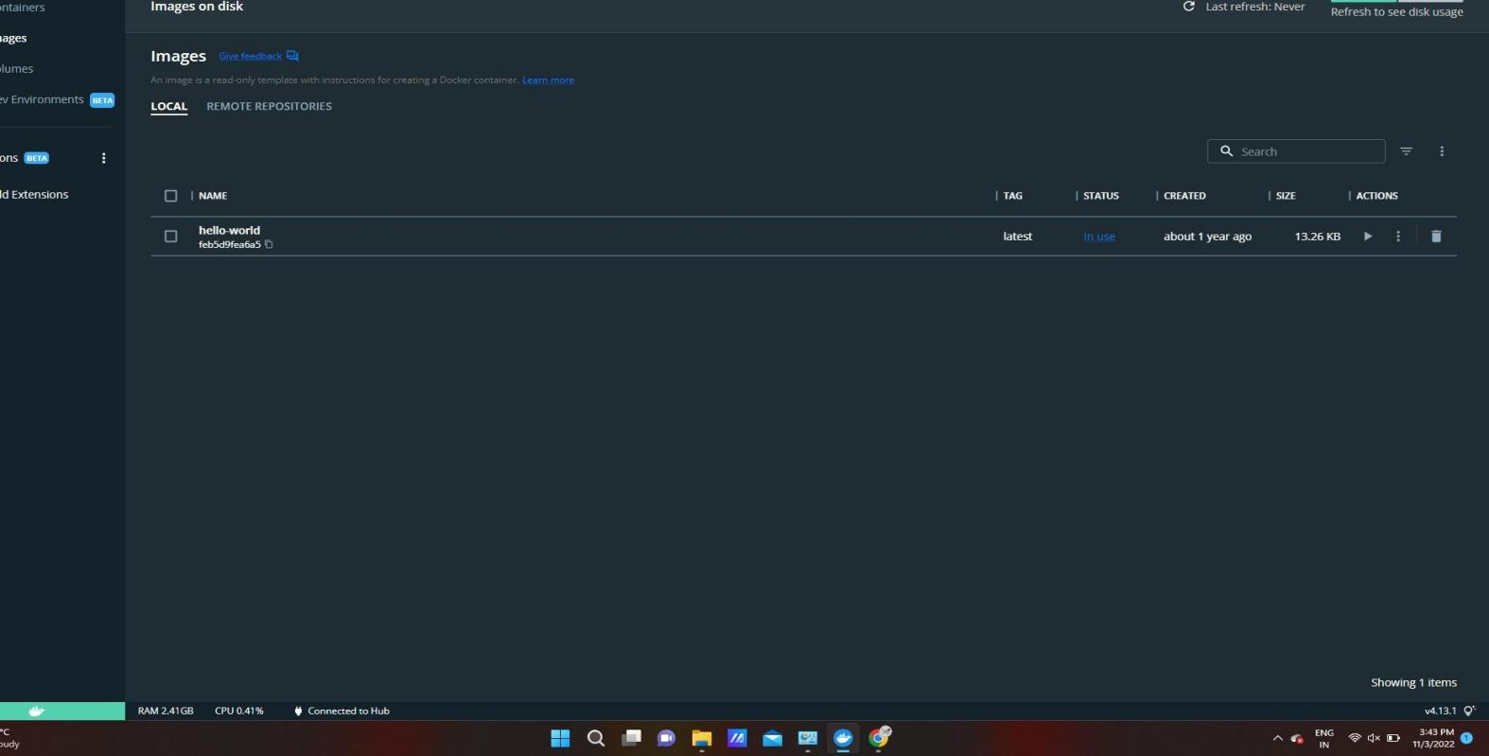

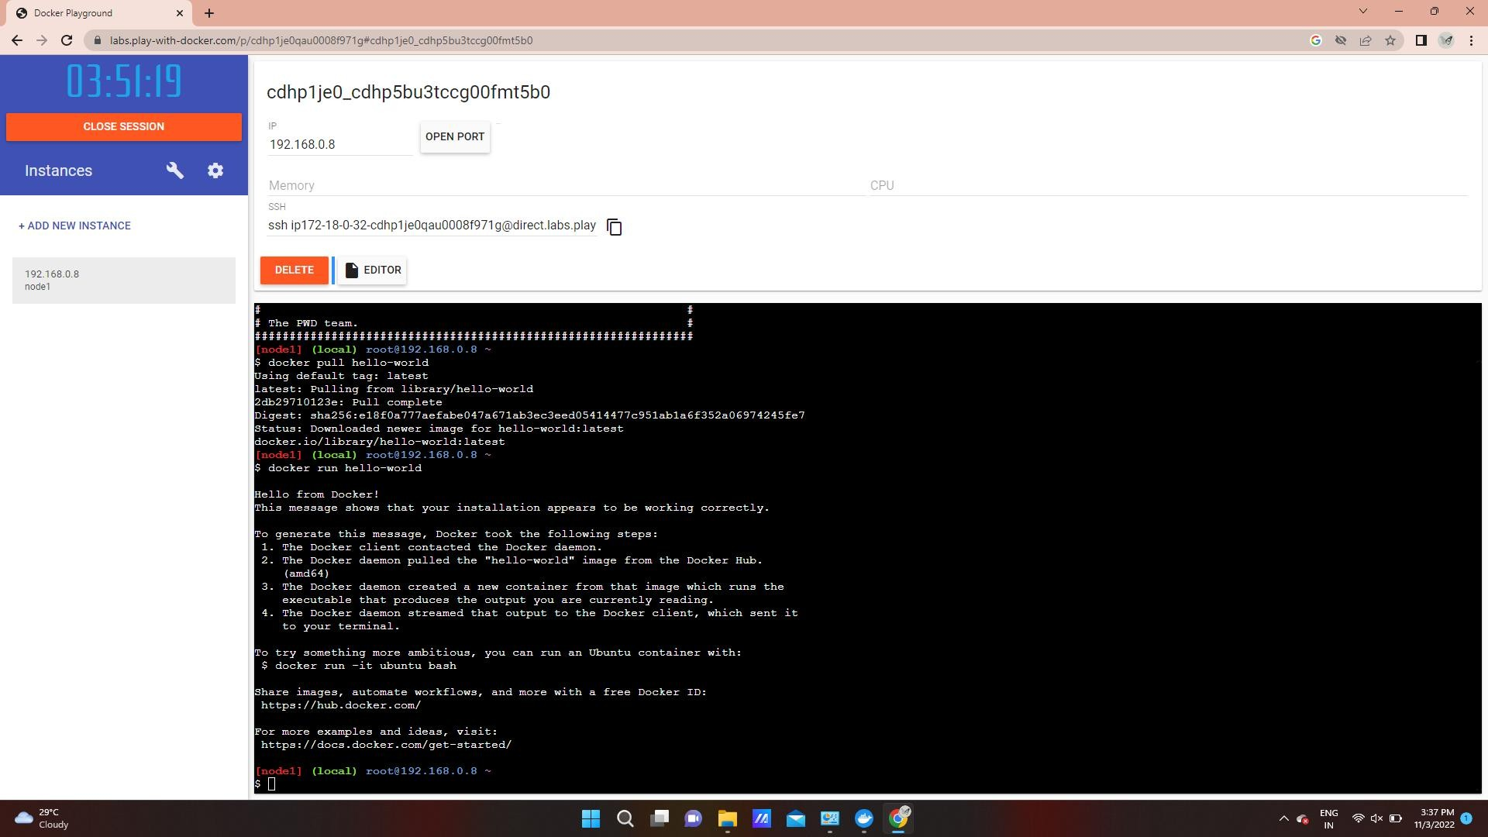

1. Create a docker file for the jobportal application and deploy it in Docker desktop application.

